Tech gadgets and its brand perception – AN ANALYSIS

**1.Abstract**

**Thesis purpose:** The thesis purpose is to examine the interrelationship of consumer and brand relations. The main objective is to research how consumers perception of brand varies before and after purchasing and how it influences their relation to brands in different aspects with their experiences and familiarities.

**Methodology:** The thesis has deductive quantitative research approach, since it starts from theory to gain more understanding of the research area. The data is collected through an online questionnaire.

**Theoretical perspective:** This study is based upon the general brand of commonly used tech gadgets and branding definitions, with focus on brand personality, consumer perception and findings

**Empirical data:** The study is investigated quantitatively. An online questionnaire was used to gather the empirical data.

**Keywords:** Brands, Brand Personality, Consumer Perception, Tech gadgets

**2. Problem Statement**

  Finding the best branding for each of the six tech gadgets and to interpret which brand stays common among the people and the reason behind the success of the brand.

**3. Introduction**

  The Technological Revolution changed the world to another dimension .Everyone has electronic gadgets and IOT now . But there comes a question among the technophile which tech gadget to buy based on the expected specifications of the consumer. There comes the marketing strategies of the different Tech Brand Companies for each of the Gadget. Manufacturers of electronic brands tend to focus on technology with little consideration for customer needs. We have researched customer preference in order to learn more about customer needs in an effort to reduce the gap between technology and customer-needs. This study aims at ascertaining the Consumer perception towards six different tech Gadgets namely Mobile Phone, Camera, Laptop, Mouse, Headphones .A formal survey has been conducted in order to gather the information required for this study. 119 responses have been collected for this study using online survey facility. This study will be helpful to understand how a consumer think about an electronic product and what are the main factors influenced a consumer to buy an electronic brand’s product.

This research paper also focused on the success of those companies which is preferred by most of the customers and predicting their marketing strategies by data analytical tools with the obtained data.

**4. Methodology used**

* 1. Multiple Linear Regression
  2. MANOVA
  3. Factor Analysis

**5. Software Used**

The entire project is carried out in JUPYTER NOTEBOOK with KERNEL:R version 4.1.3.

**6. Experimental Analysis**

**6.1 Data set used (with description)**

The dataset used is collected through questionnaire that has got 129 responses.

It is a brand wise data about the perception of a gadget that the respondent have. The age group of respondents is 18-36 and the data has a classification of gadget users and non-users.

The Gadget: Laptop dataset is taken as a part and MLR, MANOVA and Factor analysis is performed after data preprocessing.

The description of columns(variables used) in the dataset is given below,

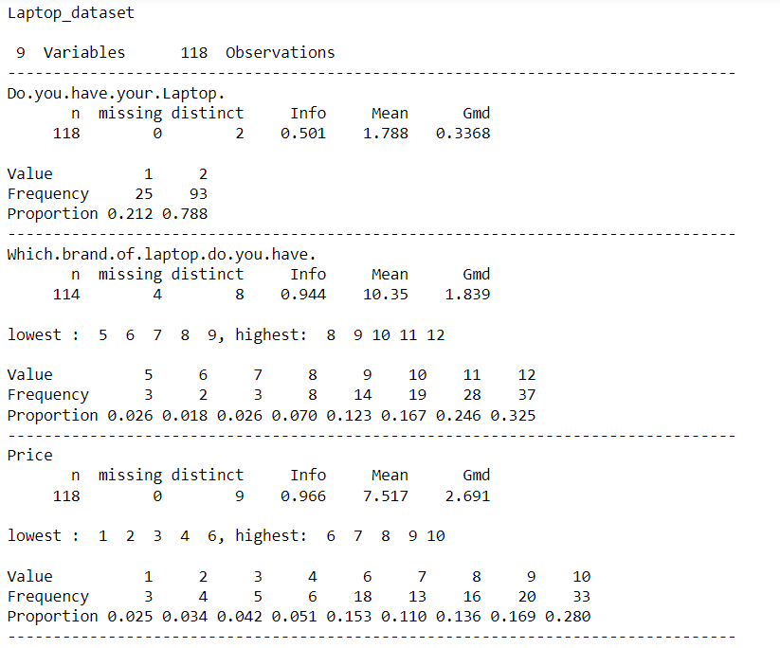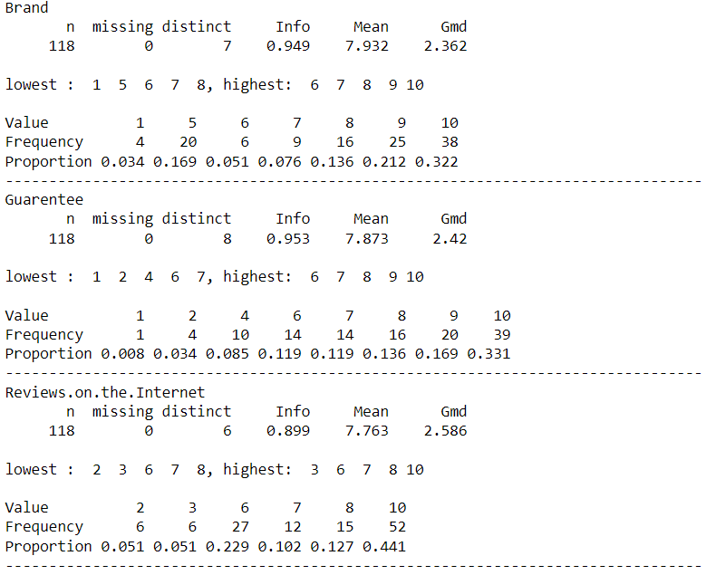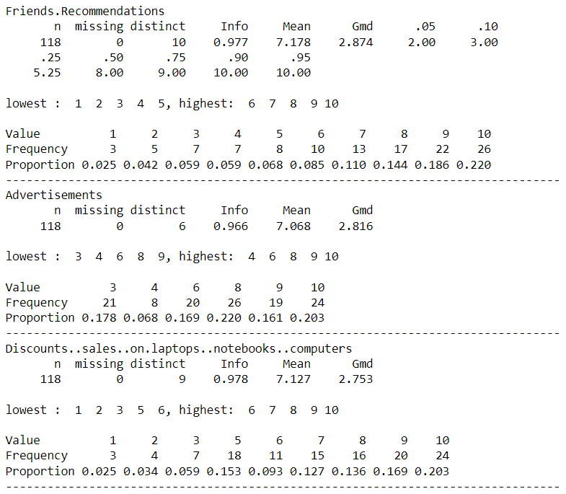

**6.2 Source Code , RESULT and interpretation**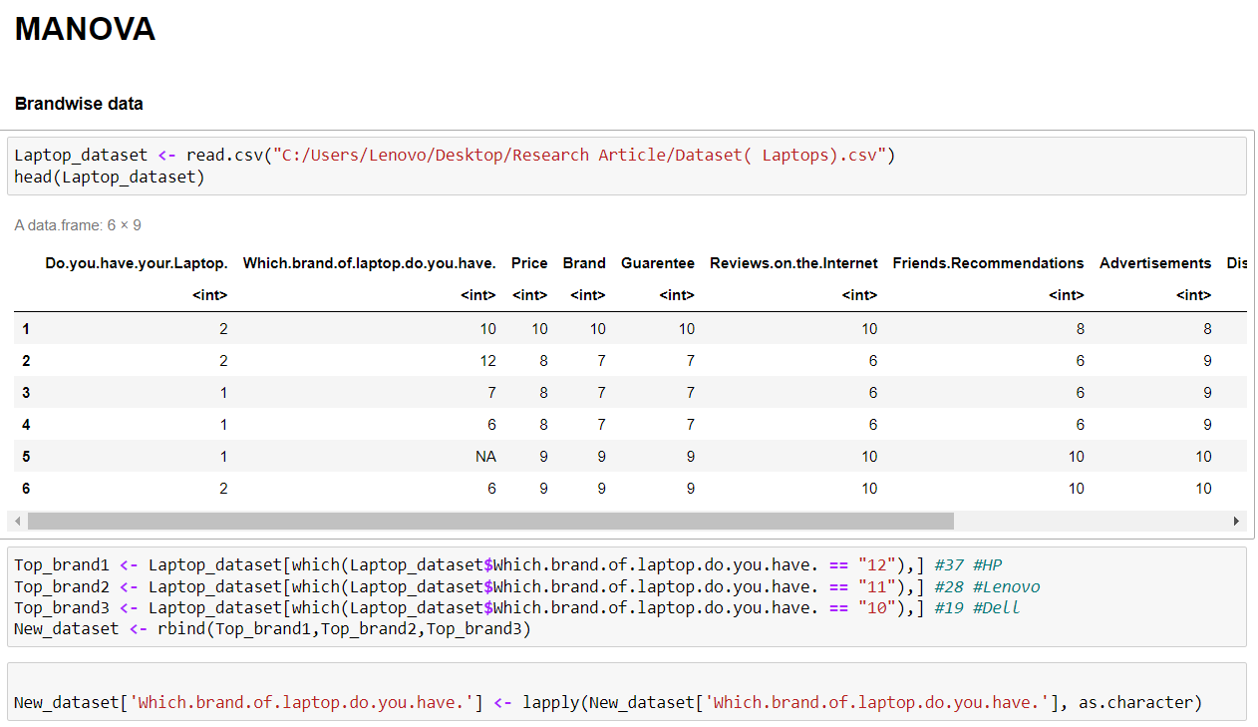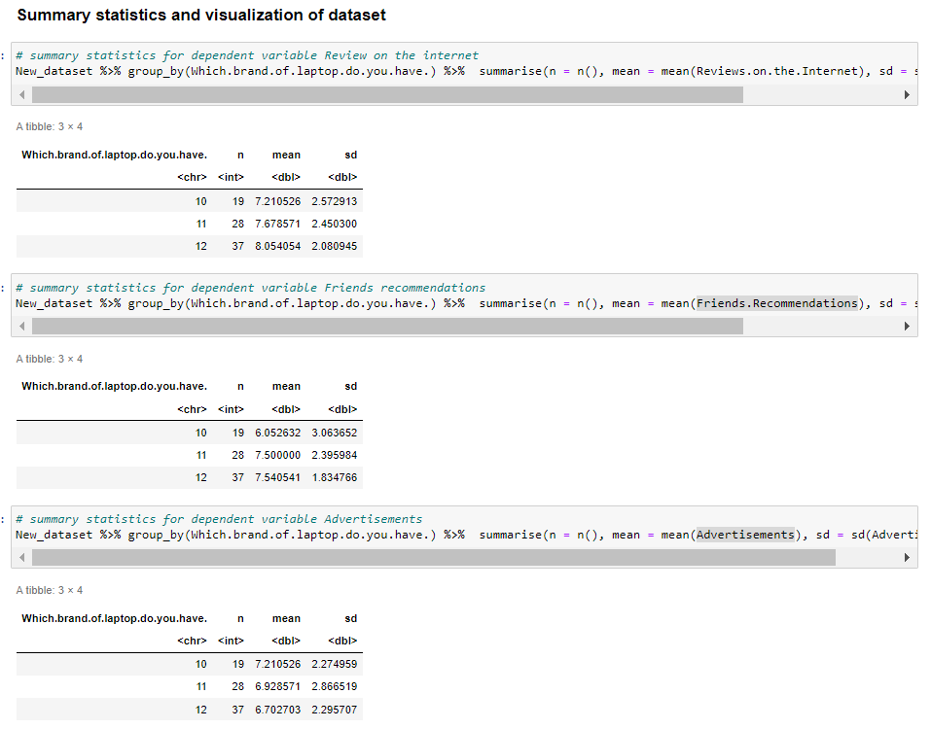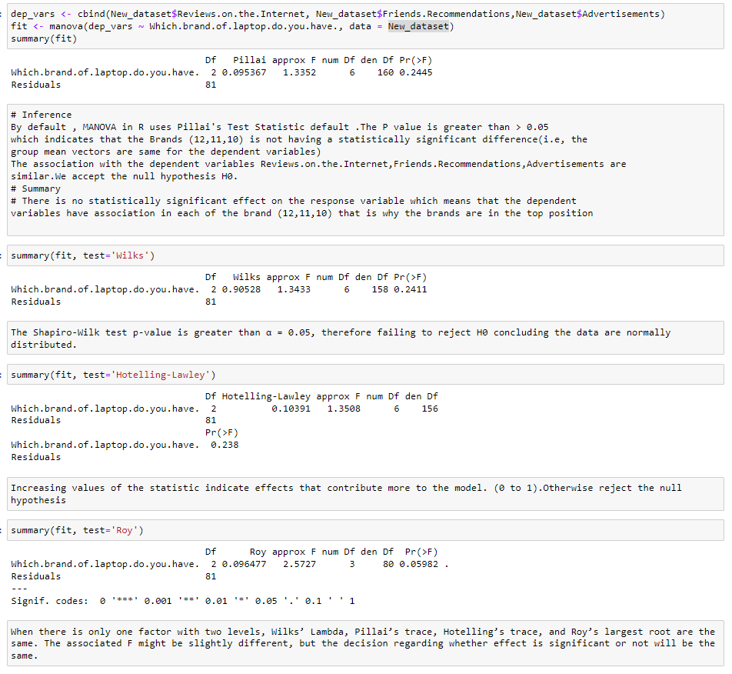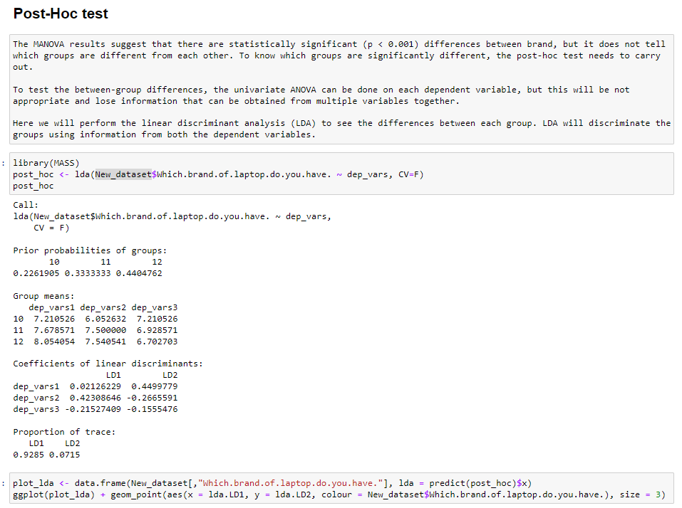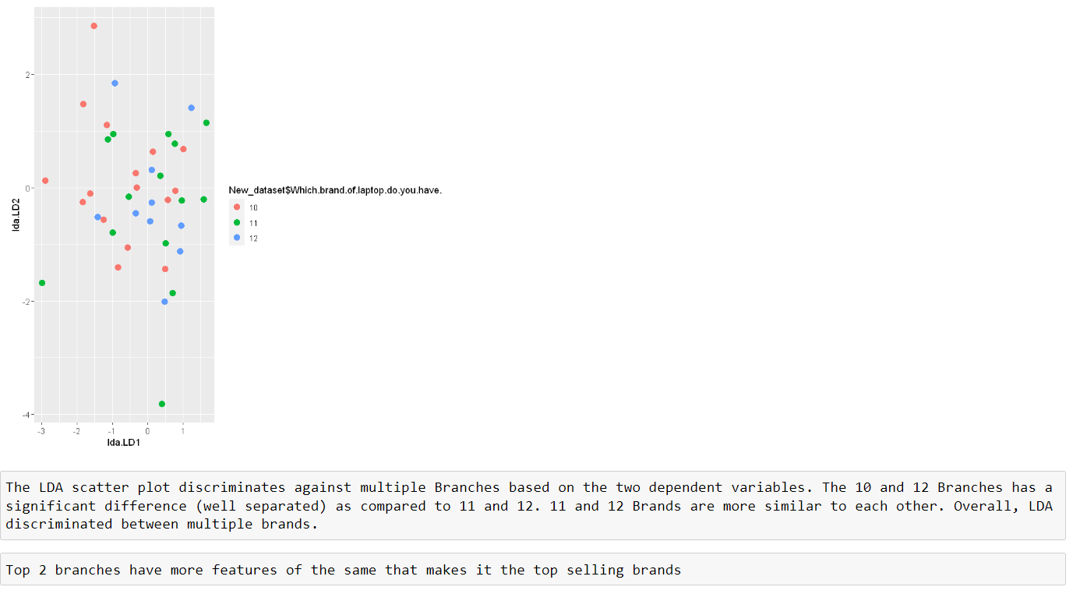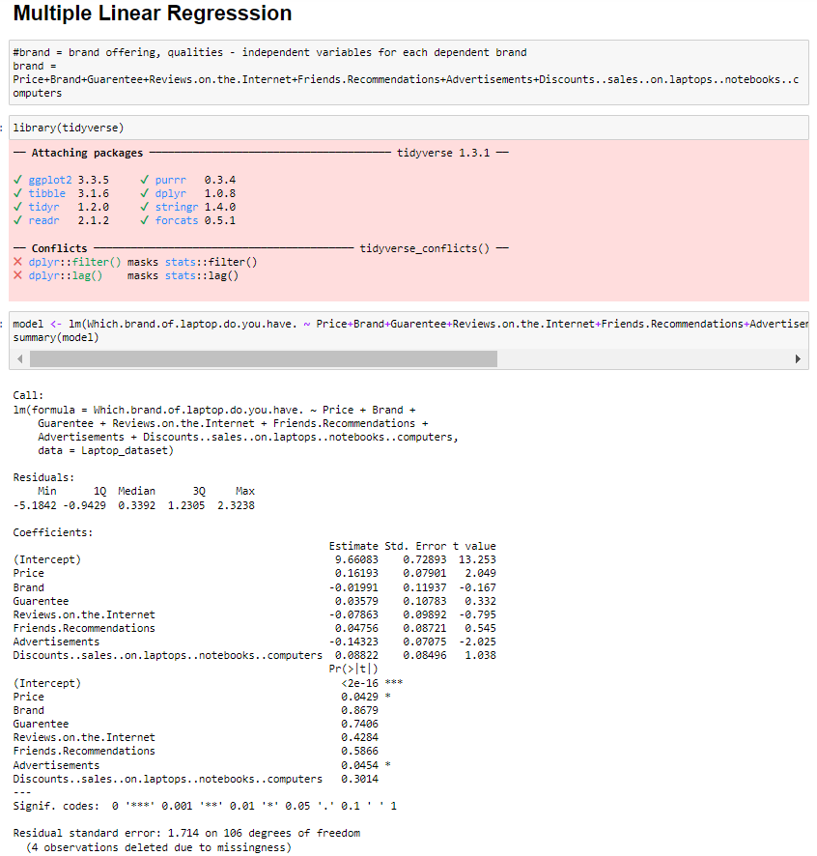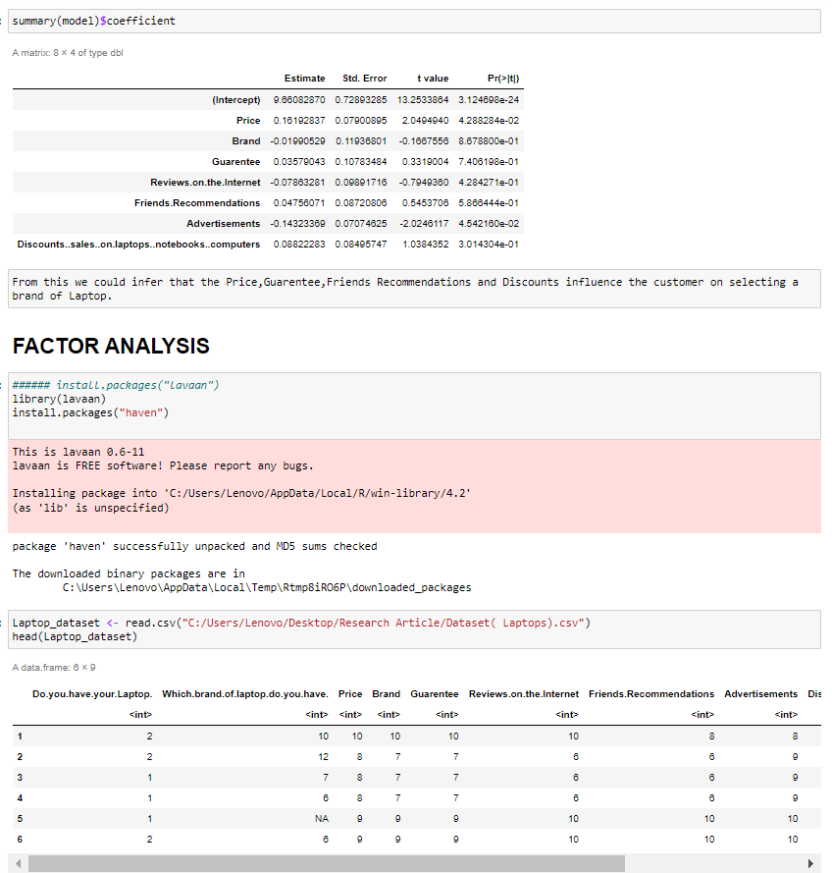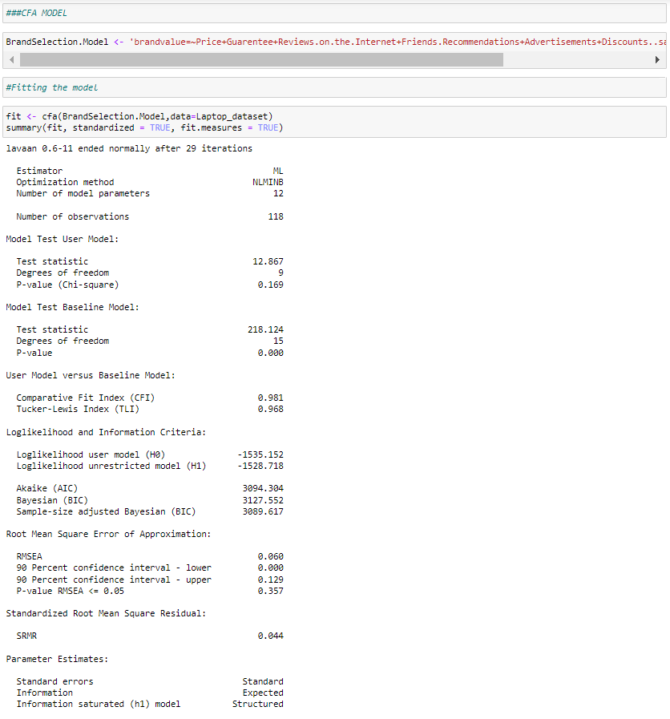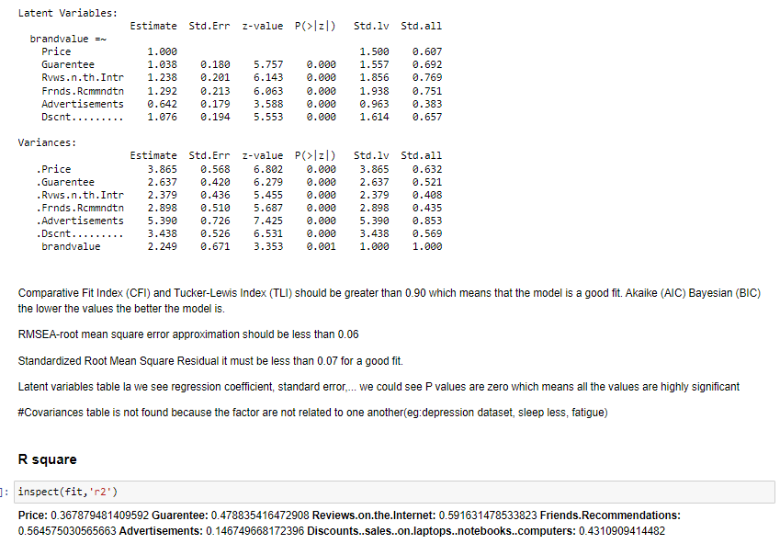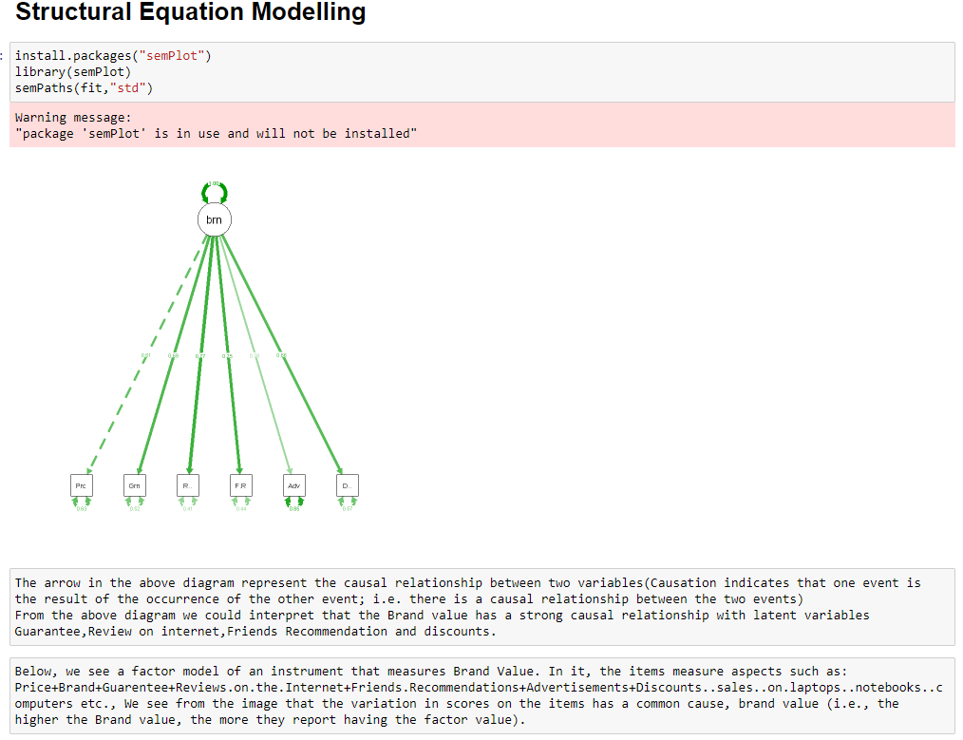

**7. Conclusion**

This study provides a broad overview about consumer perception of different tech gadgets brand and what is their relation to brands after purchasing the gadgets.The research contributes to brand personalization and studies demonstrating that how strong the consumer-brand relationship is. However, it is also shown that consumers are inconsistent in their perception of brand personas and that relation to brands is highly brand specific.

**8. Reference**

* [**https://clootrack.com/knowledge_base/what-is-customer-perception/**](https://clootrack.com/knowledge_base/what-is-customer-perception/)
* [**https://www.hbs.edu/faculty/Publication%20Files/ChatterjiToffel2019_54e9c8ad-cce3-4b6f-bf6e-8789f3a6b8b2.pdf**](https://www.hbs.edu/faculty/Publication%20Files/ChatterjiToffel2019_54e9c8ad-cce3-4b6f-bf6e-8789f3a6b8b2.pdf)
* [**https://www.researchgate.net/profile/Qasim-Nisar/publication/308746219_Impact_of_Brand_Image_and_Advertisement_on_Consumer_Buying_Behavior/links/57ede0b008ae03fa0e829f63/Impact-of-Brand-Image-and-Advertisement-on-Consumer-Buying-Behavior.pdf**](https://www.researchgate.net/profile/Qasim-Nisar/publication/308746219_Impact_of_Brand_Image_and_Advertisement_on_Consumer_Buying_Behavior/links/57ede0b008ae03fa0e829f63/Impact-of-Brand-Image-and-Advertisement-on-Consumer-Buying-Behavior.pdf)
* [**https://www.quirks.com/articles/how-to-update-a-brand-tracking-study**](https://www.quirks.com/articles/how-to-update-a-brand-tracking-study)
* [**https://core.ac.uk/search?q=Brand%2Bperception**](https://core.ac.uk/search?q=Brand%2Bperception)  
  [**https://shodhganga.inflibnet.ac.in/bitstream/10603/207762/18/18_%20appendix%20a.pdf**](https://shodhganga.inflibnet.ac.in/bitstream/10603/207762/18/18_%20appendix%20a.pdf)